

Data Technician

Name: Saharsh Jakkula
Course Date: 08/09/25
Table of contents
Day 1: Task 1 2
Day 2: Task 1 2
Day 2: Task 2 3
Day 2: Task 3 4
Day 3: Task 1 4
Day 3: Task 2 5
Dataset: 5
Step 1: Create a Pivot Table 5
Step 2: Use the SWITCH Function 5
Submission: 6
Day 3: Task 3 6
Day 4: Task 1 7
Course Notes 9
Additional Information 10

Day 1: Task 1

Please complete the below boxes on commons laws and regulations that must be followed when working with customers data, use the below bulleted list to support your answers.

- What is it
- Why is it important
- Provide a real-world example of how you can follow it
- How does it impact working with data
- What could happen if you breached it

Data Protection Act | The Data Protection Act 2018 is the current UK law governing how personal data is collected, stored, and processed, ensuring it’s handled fairly, lawfully, and securely to protect individual privacy. It is important to protect people’s privacy and ensure personal data is handled responsibly in the digital age.  For example: A hospital that collects patient’s medical records for treatment purposes should:  1. Obtain consent from the patient  2. Store the data securely  3. Limit access to the data only to authorized staff  4. Allow patients to access and correct their personal data if it isn’t accurate  5. Not to share patient information with third parties unless legally required.  A breach of the data protection act can lead to a fine, reputational damage, and possible legal action with sanctions.
GDPR | The General Data Protection Regulation is a European Union regulation that regulates how organisations in the EU/EEA collect, use, store and share personal details, while also protecting individual’s personal data and give them more control over information.  It is necessary so that companies operating in the EU:  1. Ask consumers for consent before sending marketing material.  2. Showing a cookie consent banner before collecting browsing data  3. Allowing users to download or delete their data upon request  4. Ensuring the data is stored in servers secure as per EU/EEA standard  A breach of the GDPR can lead to heavy fines, legal action, reputational damage, and restrictions on data collection/usage.
Freedom of Information Act | The Freedom of Information Act 2000 is an act of the Parliament of the UK that creates a public right of access to information held by public/governing authorities. It aims to promote transparency, accountability, and trust between the government and the citizens of the UK.  The act brings responsibility to public authorities to:  1. Regularly publish updates and information regarding their activities.  2. Ensure members of the public can make requests for information and updates regarding the activities of public authorities.  An example of public authorities under the governance of FOI act in the UK include the NHS, police, government departments and state schools. FOI can be restricted on the case of the information being classified, or filing the request being unreasonably difficult.  A breach of the Freedom of Information Act can lead to public distrust, and the public’s reasonable grounds to take legal action.
Computer Misuse Act | The Computer Misuse Act 1990 is an Act of the Parliament of the UK to make provision for securing computer material against unauthorized access or modification. It is necessary to protect computer systems from malicious users who try to either gain unauthorised access, including mere physical contact and the scrutiny of data without any interaction with a computer. This is known as ‘hacking’.  This act incentivizes to:  1. Make individuals strong passwords and two-factor authentication to prevent unauthorized access  2. Have organisations monitor systems for hacking attempts and reporting breaches to relevant authorities  3. Prohibiting installation of malware or malicious software on company devices  4. Restricting access to sensitive information to only authorized authorities.  5. Logging network activity to detect and prevent cyber-attacks  A breach of the Computer Misuse Act can lead to fines, criminal charges or imprisonment depending on the severity of the breach.

Day 2: Task 1

Please research and complete the following tasks within the retail-sales_dataset.xlsx document, paste a print screen into the provided boxes below:

- In the sheet ‘retail_sales_dataset’ add all available data between columns A –J into a ‘table’
- Using the ‘sort’ function, sort ‘Age’ to ‘largest to smallest’
- Using the ‘SUM’ function, show me the commission total in cell ‘L10’
- Using the ‘AVERAGE’ function, show me the average commission in cell ‘L11’

Print screen 1 | 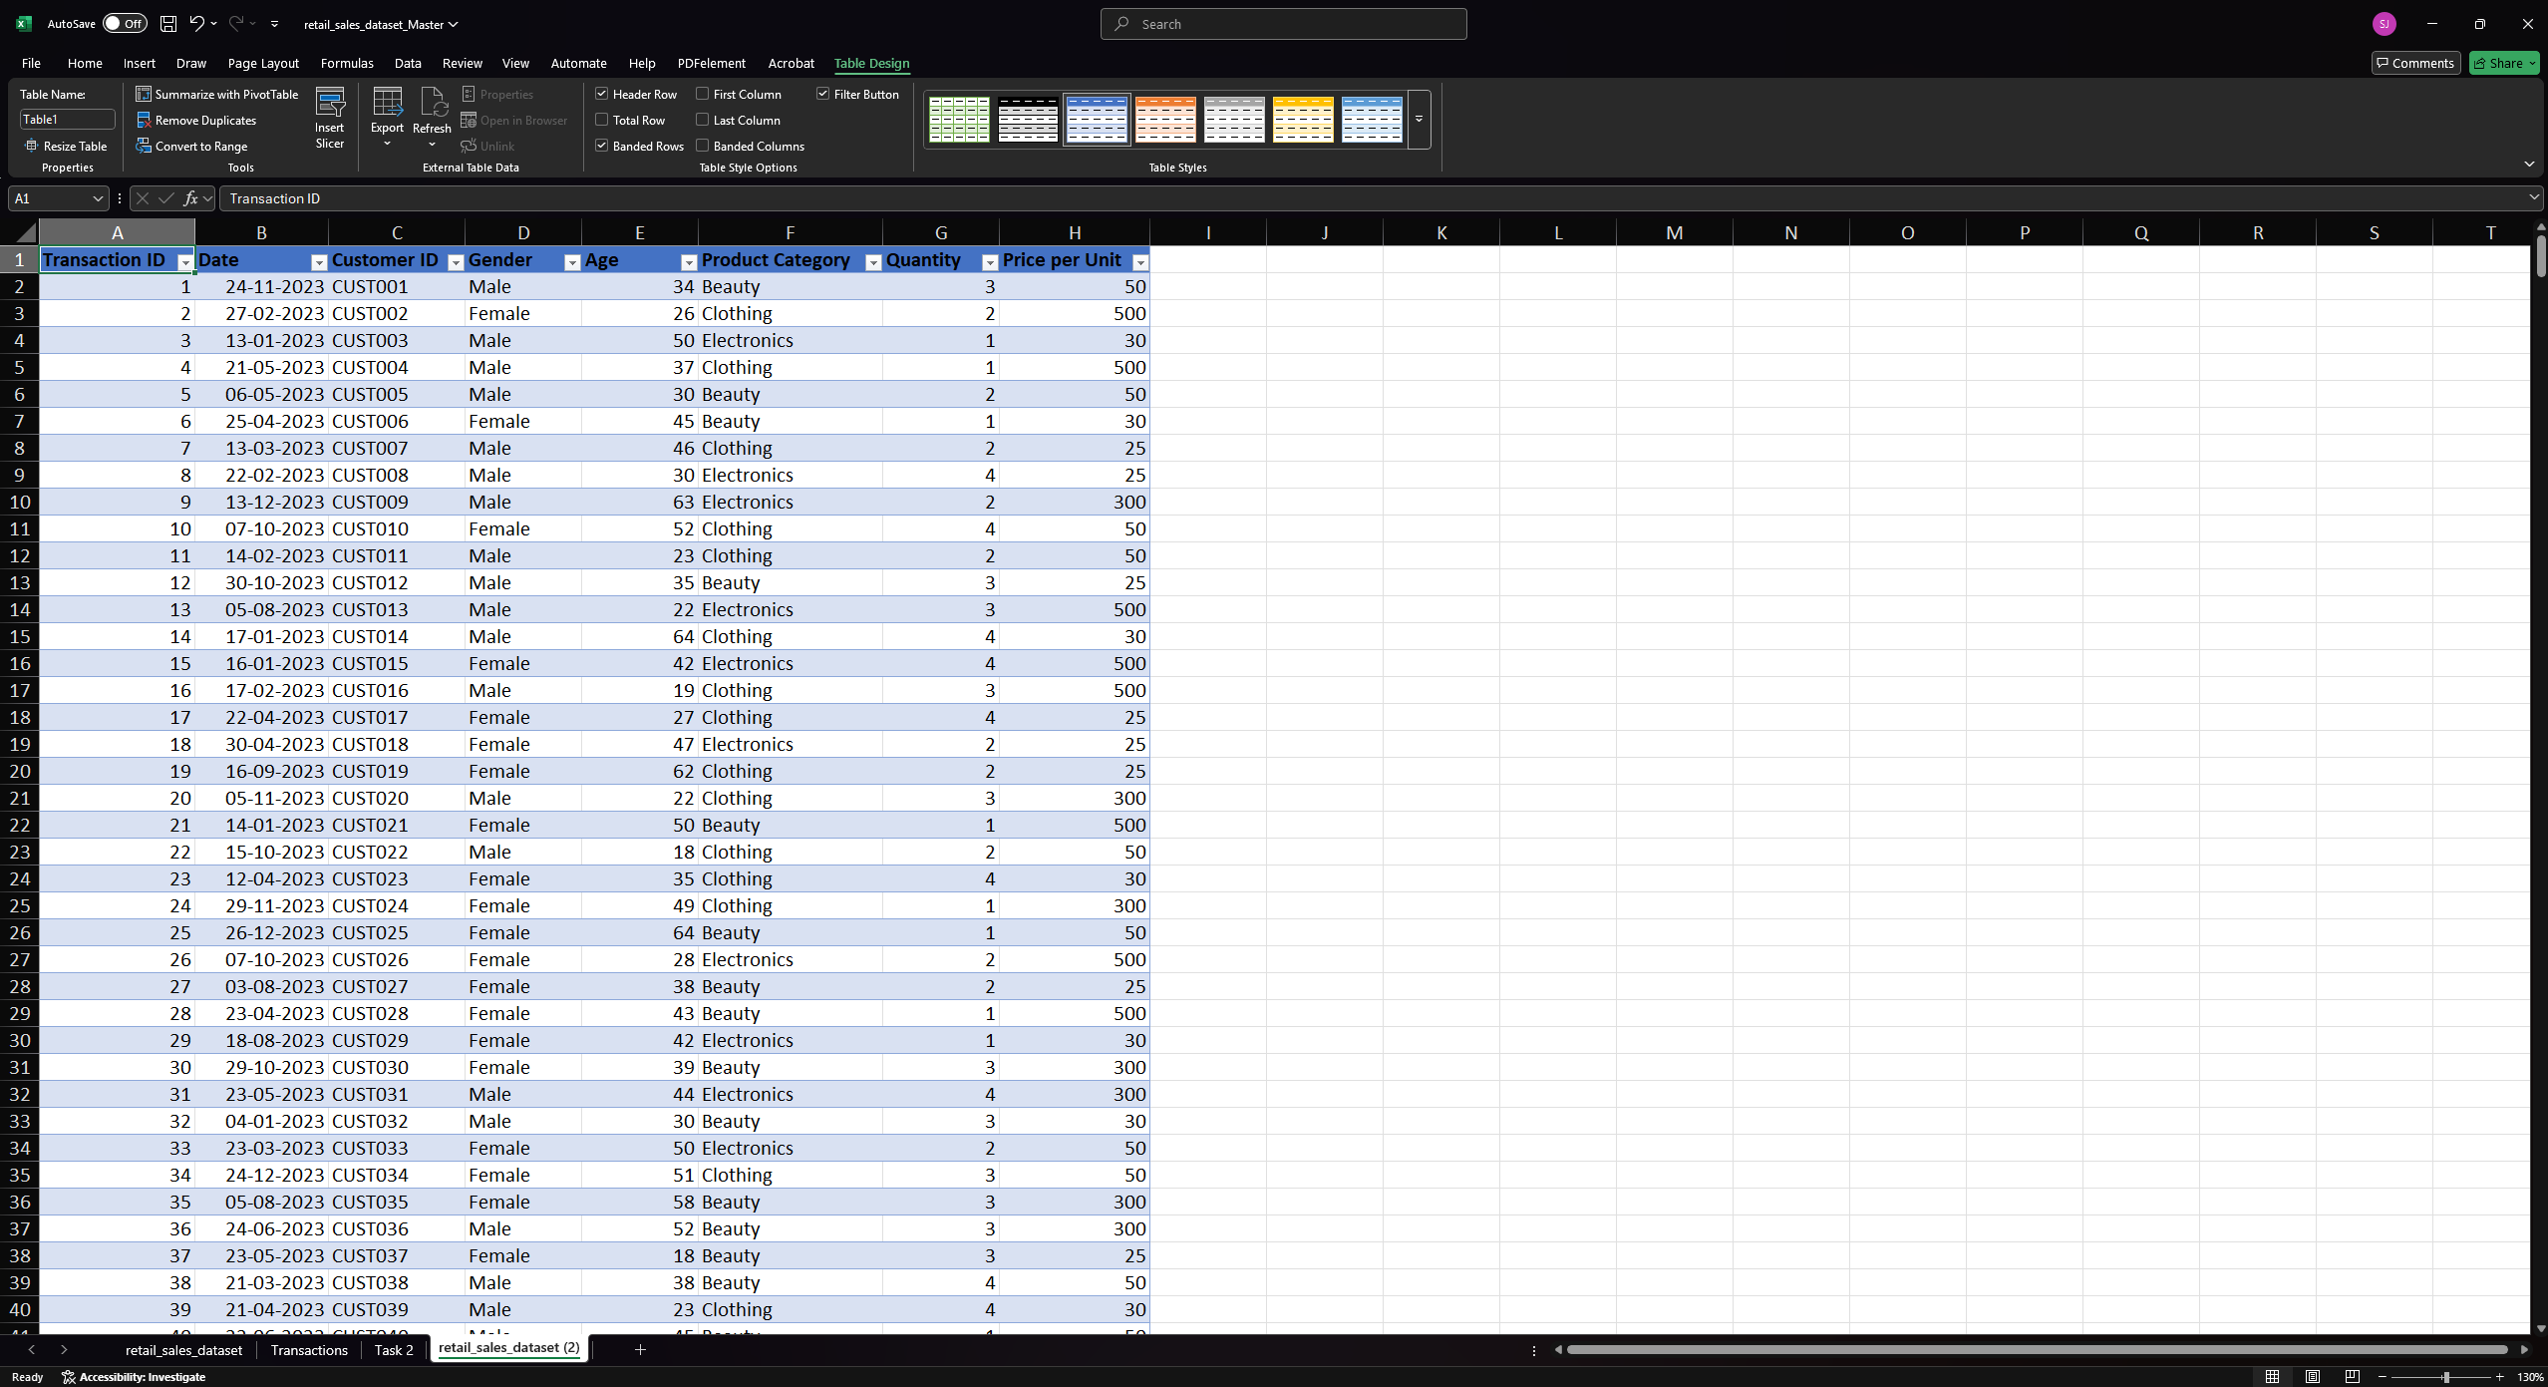
Print screen 2 | 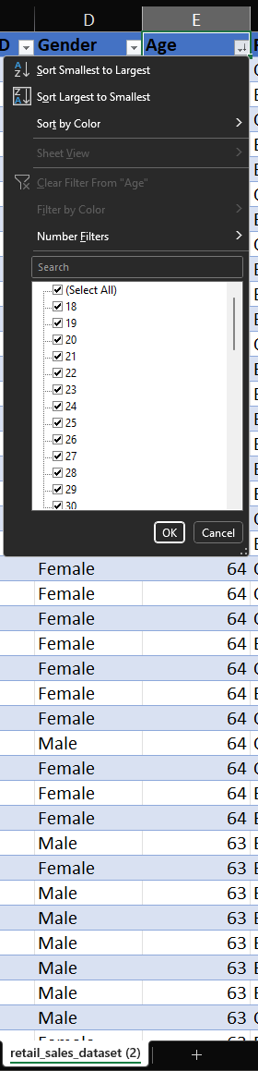
Print screen 3 | 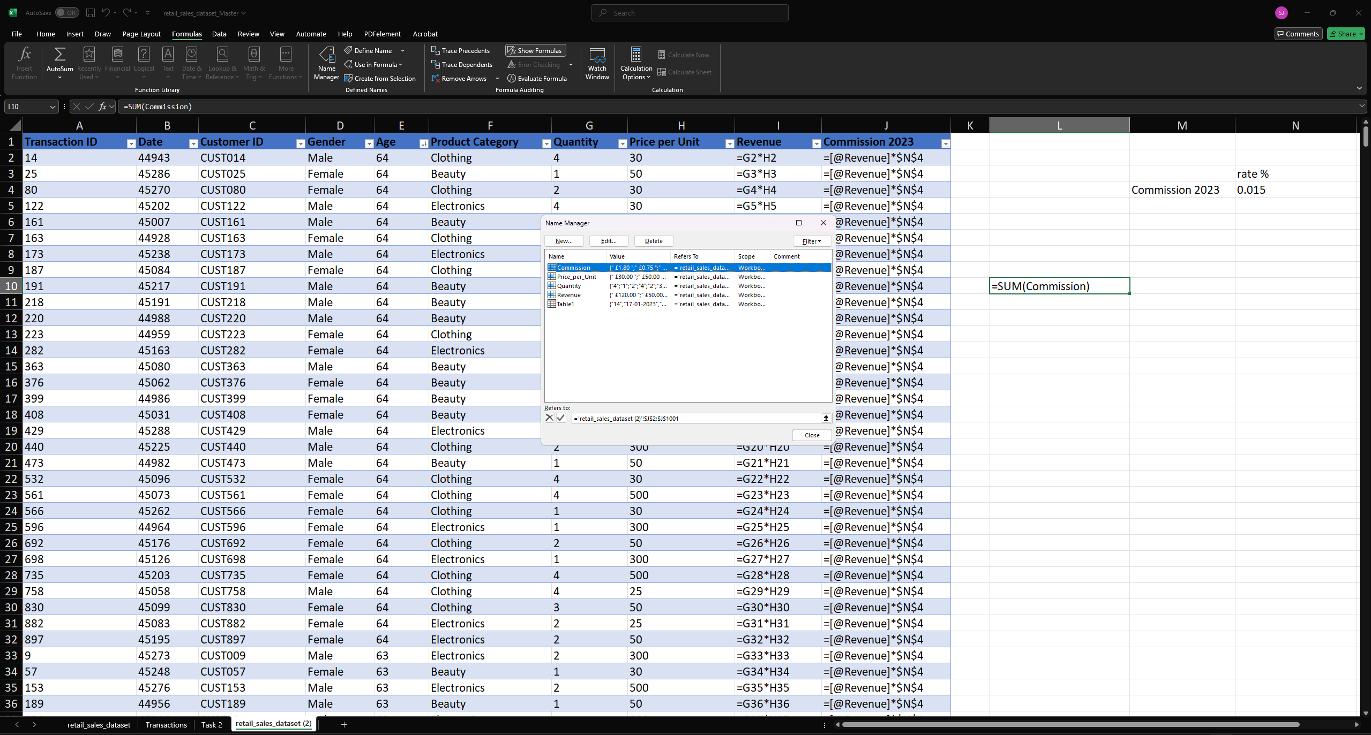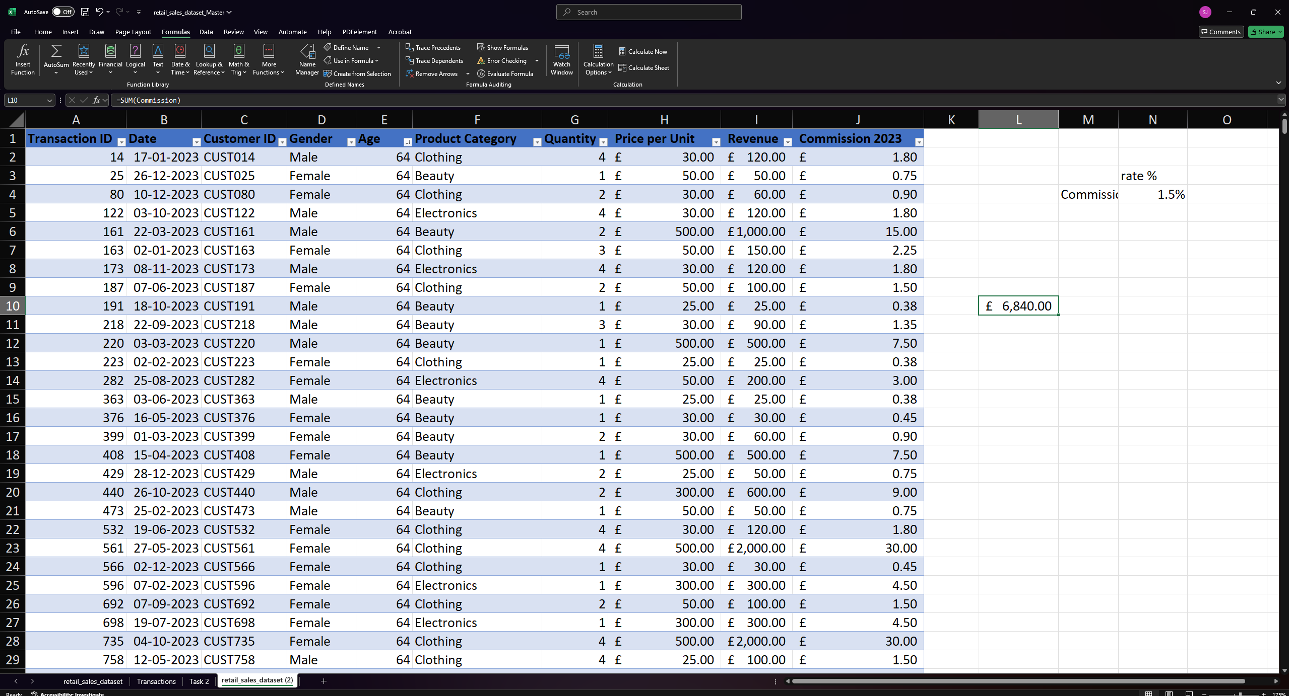
Print screen 4 | 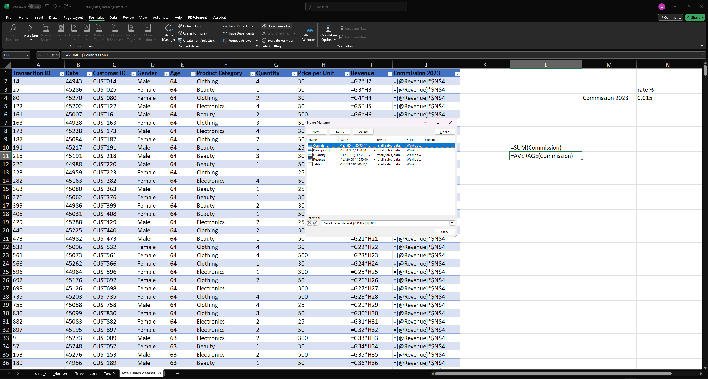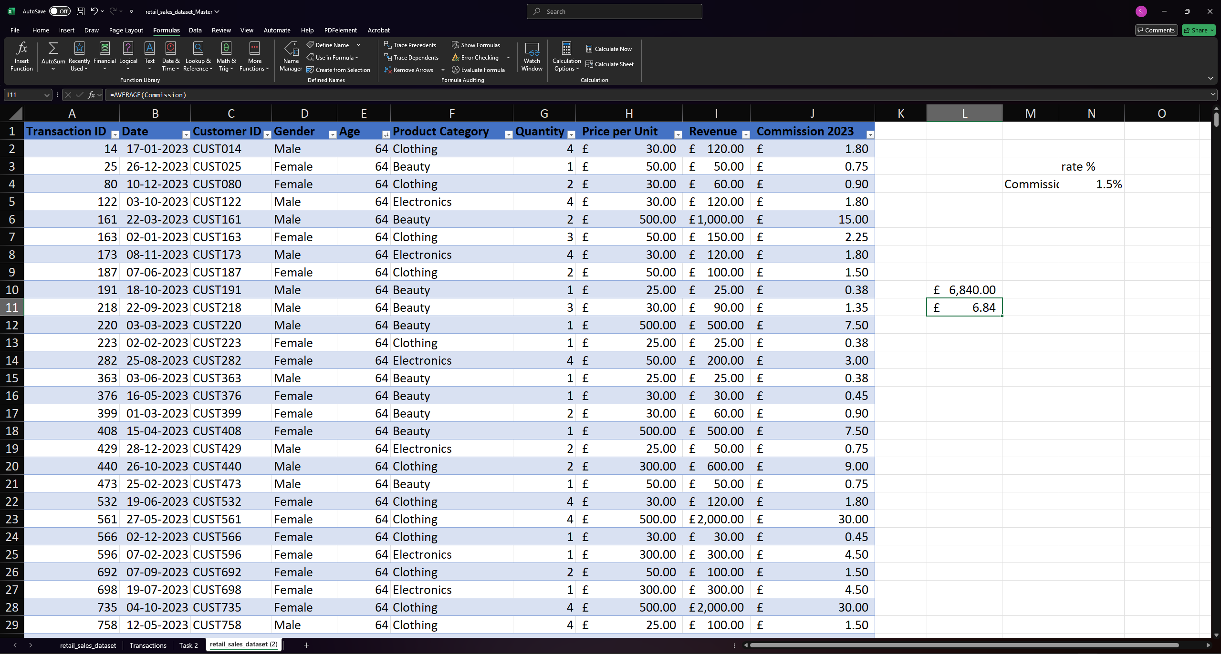

Day 2: Task 2

Please research and complete the following tasks within the retail-sales_dataset.xlsx document, paste print screens into the provided box below:



Print screen 1 | - 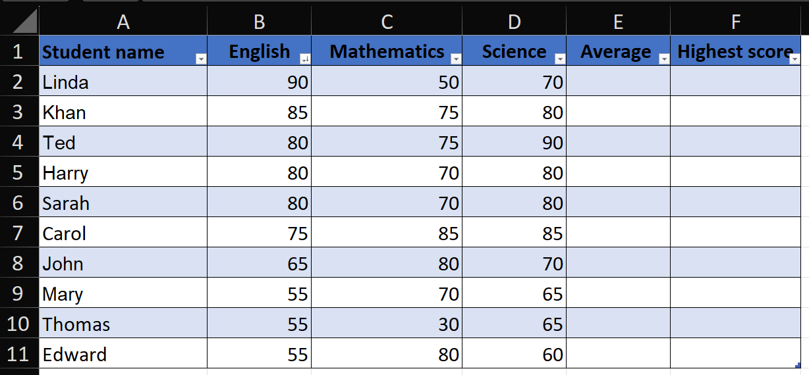  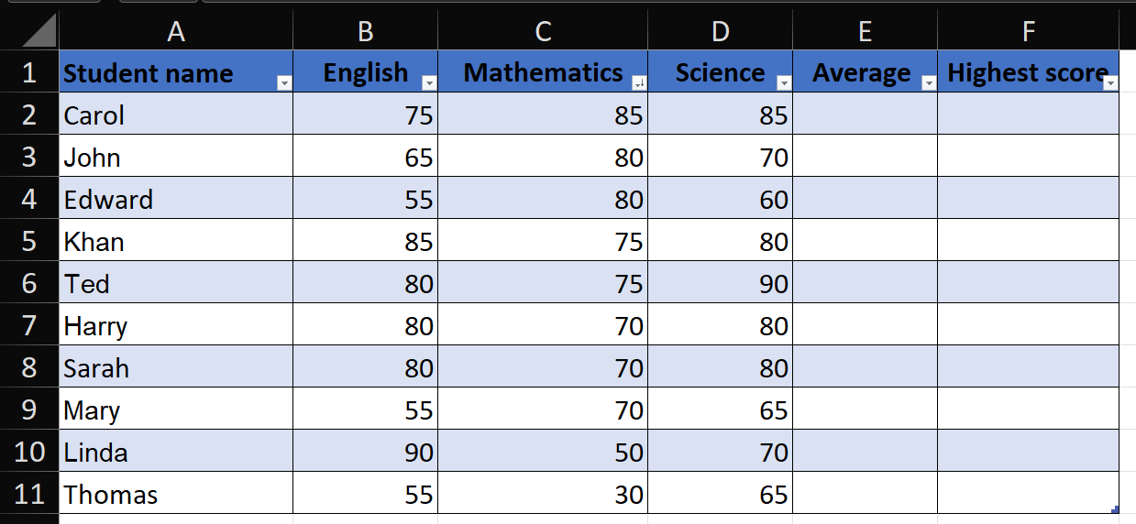  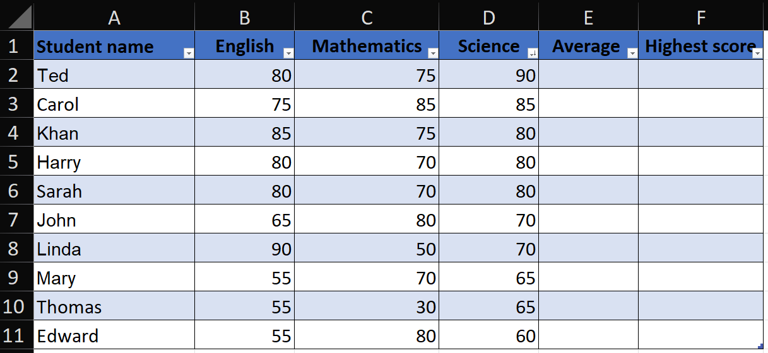  - 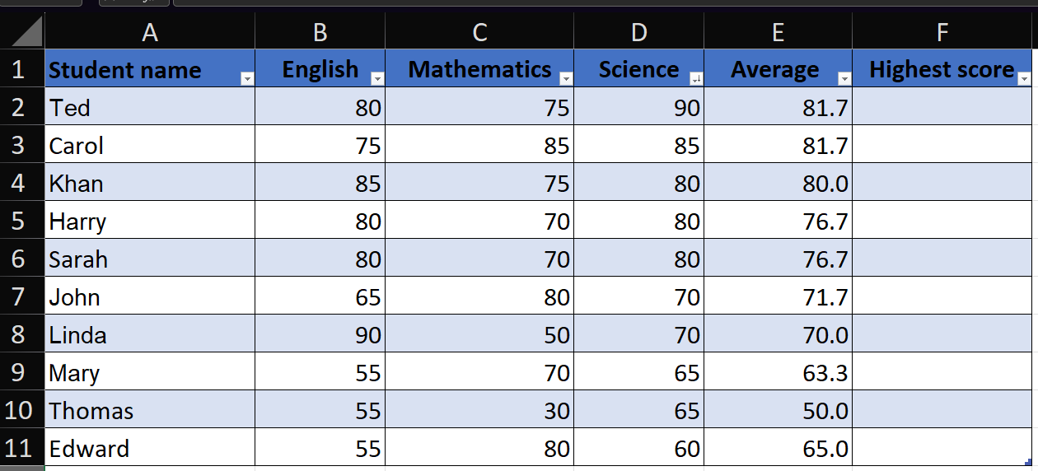  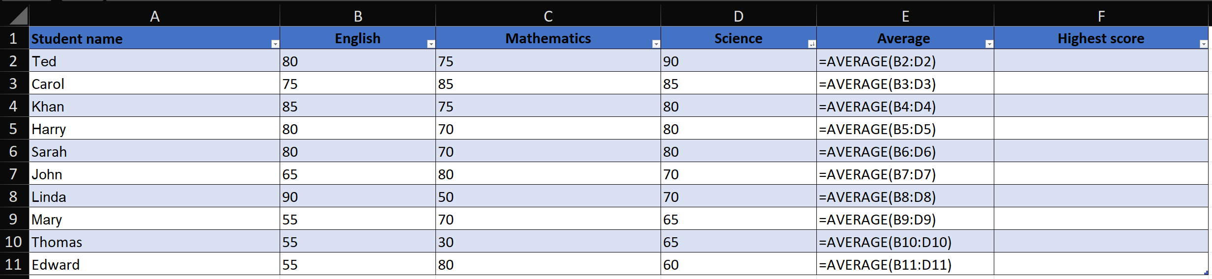  - 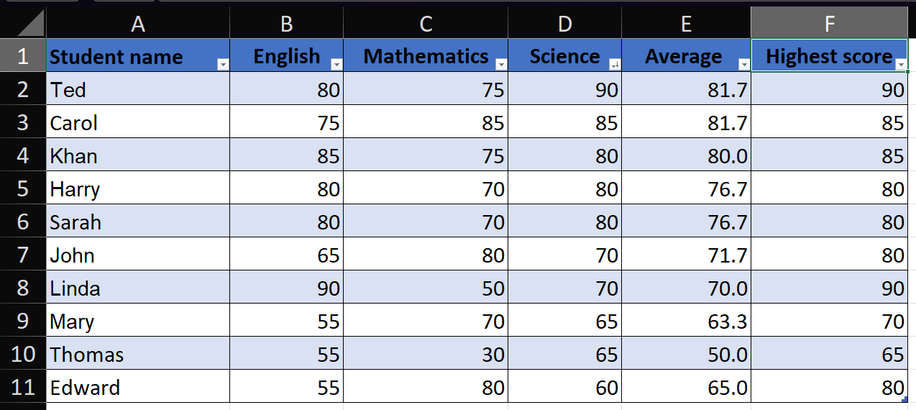  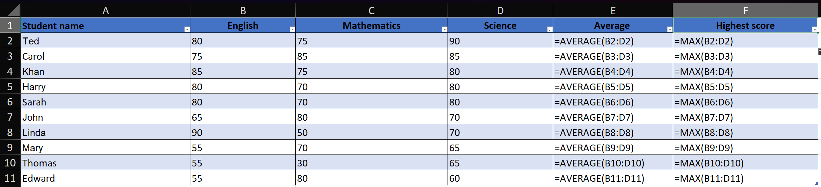  - 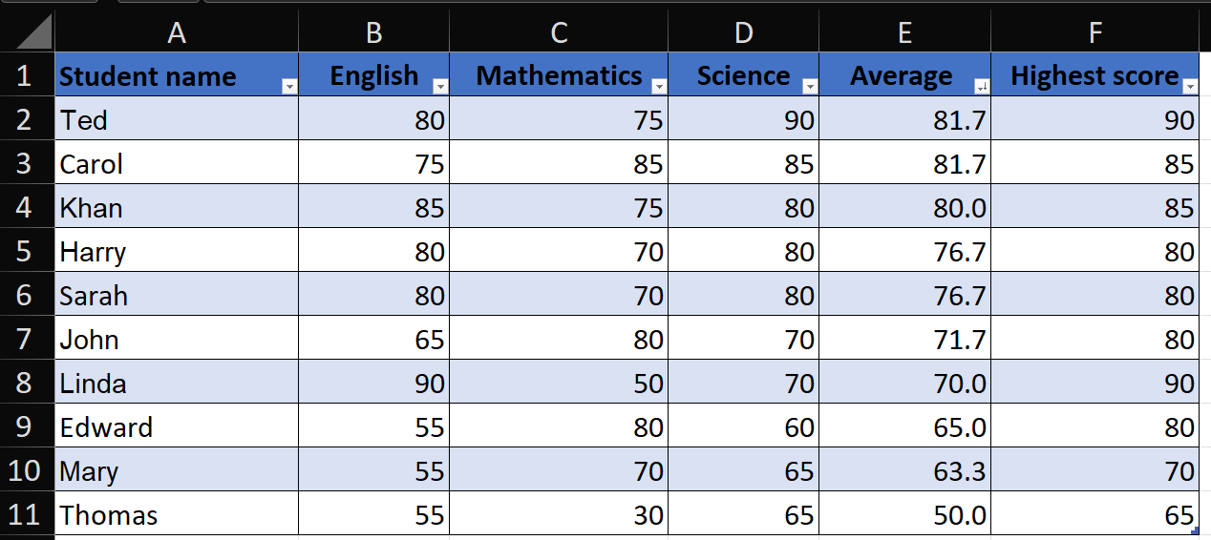  - 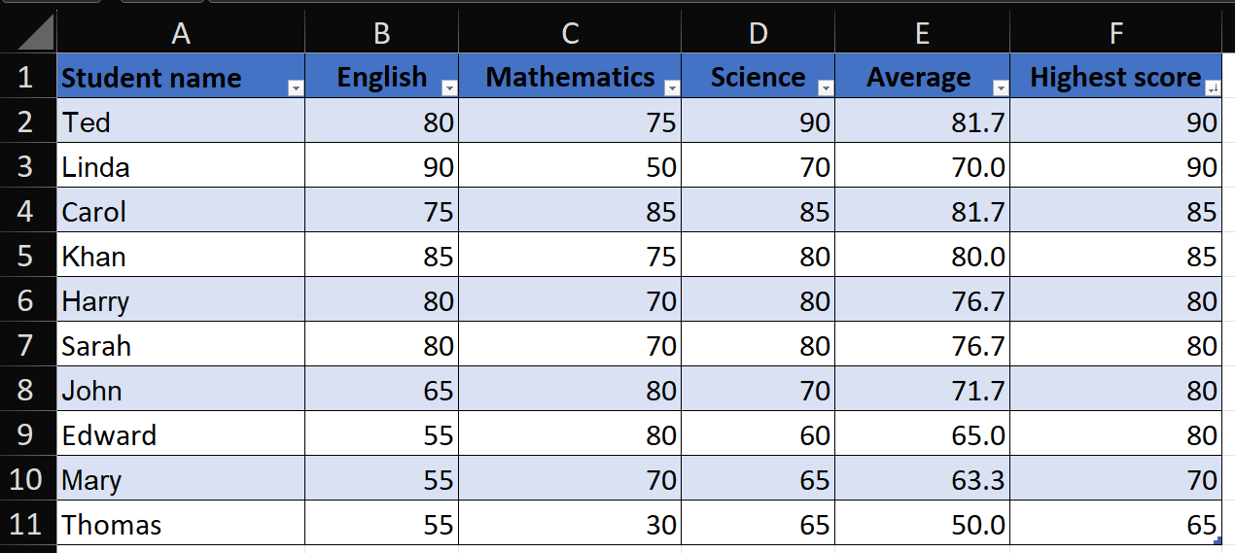  - 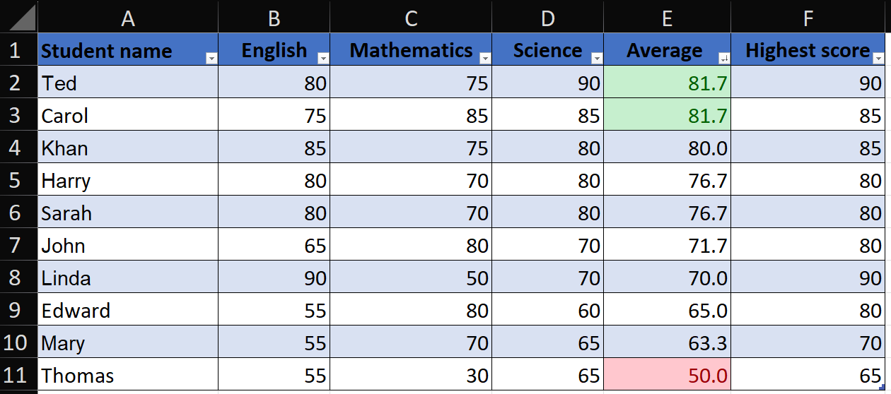

Day 2: Task 3

Using the skills developed today, have some fun with the data set you have imported. Paste your work below and enjoy!

Print screen 1

Day 3: Task 1

Please download the dataset ‘Day_3_Task_1_Bike_Sales_Pivot_Lab.xlsx’ and the lab instructions.

Do not worry if you do not complete the lab, just working with data and playing with the pivot table will be good experience.

Please paste your final pivot table below and complete the reflection questions:

Print screen 1
In which markets does Germany have customers?
What country has sales in all markets?
What are the most profitable markets by country, age group, and gender?
Any other findings?

Day 3: Task 2

The dataset below tracks the sales performance of different products in various counties in England. Please paste the dataset into a blank Excel workbook. Your task is to:
- Create a Pivot Table to summarise the data by county and product.
- Use the SWITCH function to categorise products based on their sales volume.

Dataset:
County | Product | Sales Volume
Yorkshire | Laptops | 500
Yorkshire | Smartphones | 200
Cornwall | Laptops | 700
Cornwall | Printers | 400
Lancashire | Smartphones | 150
Lancashire | Laptops | 600
Essex | Printers | 800
Essex | Smartphones | 300
Durham | Laptops | 250
Durham | Printers | 300
Greater Manchester | Smartphones | 600
Greater Manchester | Laptops | 400

Step 1: Create a Pivot Table
- Select the dataset (columns A to C).
- Insert a Pivot Table to summarise the data by County in the rows and Products in the columns. Use Sales Volume as the value to be summarised.

Step 2: Use the SWITCH Function
In a new column next to your data, use the SWITCH function to categorise products based on Sales Volume as follows:
  - For sales greater than 600: "High"
  - For sales between 300 and 600: "Medium"
  - For sales less than 300: "Low"
SWITCH Function Example:
=SWITCH(TRUE, C2 > 600, "High", C2 >= 300, "Medium", "Low")
- Apply this formula to each row, and check if the products are categorised correctly.

Submission:
- A completed Pivot Table summarising sales by county and product.
- A new column in the dataset categorising products by sales volume using the SWITCH function.
  - Please paste your completed work below

Print screen 1

Day 3: Task 3

Please download the dataset ‘Day_3_Task_3_Bike_Sales_Visualisations_Lab.xlsx’ and the the lab instructions. Do not worry if you do not complete the lab, just working with data and playing with the charts will be good experience.

Please paste your results below:

Print screen 1

Day 4: Task 1

You have been asked to deliver your analysis findings to the board of directors, with your analysis you have identified that customers are leaving your company at the 12-month point, this is typically when they receive their renewal price.

Conduct research and complete the below questions:

How would you prepare for the delivery?
What tools would you use for the delivery?
What is prospecting and why would you complete this before your delivery?
Tell me best practices for public speaking and providing updates to senior leaders
What will you show the board in your delivery?
How will you articulate the changes that are needed?
Provide a list of online resources and videos that will support your preparation for public speaking
Evaluate tools that provide visualisation.

Tell me what they are.

Tell me what you would choose when delivering your presentation and why

Course Notes

It is recommended to take notes from the course, use the space below to do so, or use the revision guide shared with the class:

Additional Information

We have included a range of additional links to further resources and information that you may find useful, these can be found within your revision guide.

END OF WORKBOOK

Please check through your work thoroughly before submitting and update the table of contents if required.

Please send your completed work booklet to your trainer.

